CARDV
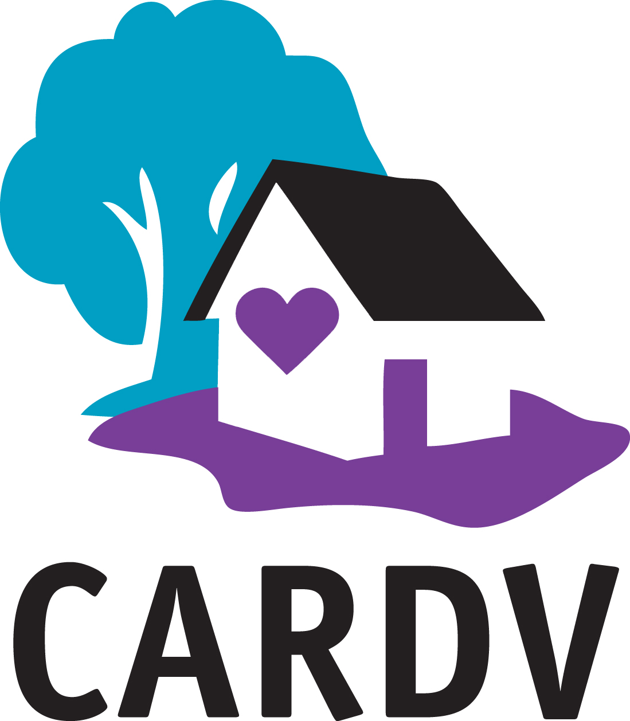
Adopted:_8/31/20
Revised:__________
Revised:__________
Board Expense Reimbursement Policy

CARDV Board of Directors reimbursement policy shall be reviewed annually by the secretary/treasurer and the Board. The organization’s travel mileage reimbursement shall be equal to the current IRS reimbursement amount.

So that the amount of the reimbursement is not considered taxable income to the recipient, CARDV will reimburse lodging expense on an actual basis provided that the amount is reasonable and receipts are attached as per CARDV standard mileage and reimbursement form available at the CARDV office.

Reimbursement is allowed for reasonable, ordinary, and necessary expenses incurred in connection with approved expenses or travel on behalf of CARDV. Any exception to this policy must be approved by the CARDV Board President.

Board Member Name: Kate Caldwell
Position: President Date: 8/31/20

