CARDV
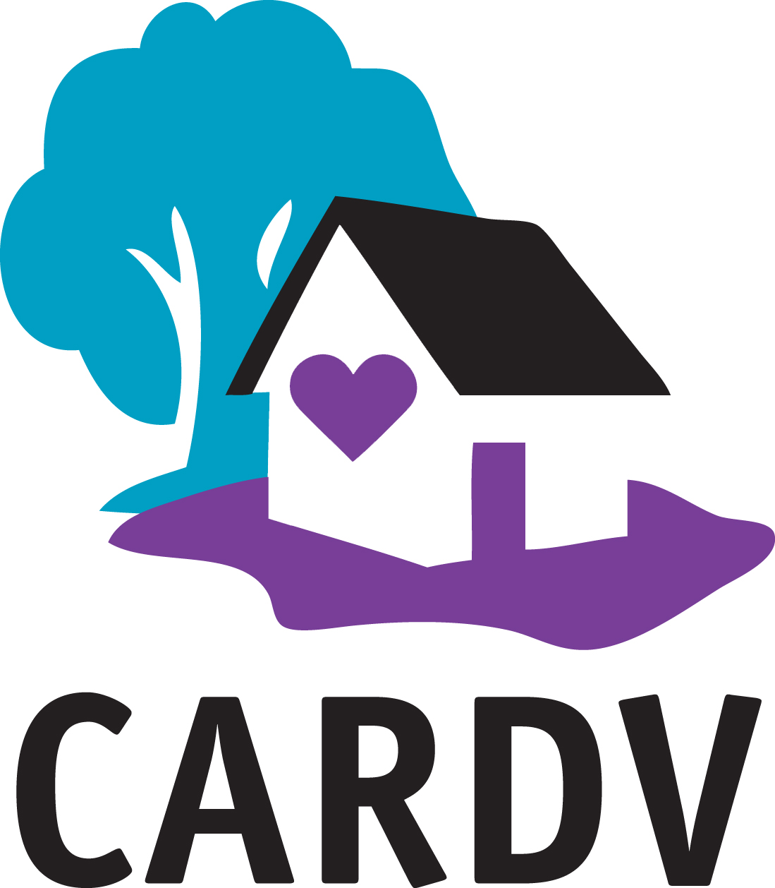
Adopted: 7/28/20
Revised:__________
Revised:__________
Lobbying and Political Activity Policy

Political Activity Policy
CARDV encourages individual participation in civic affairs. However, as a charitable organization, CARDV may not make contributions to any candidate for public office or political committee and may not intervene in any political campaign on behalf of or in opposition to any candidate for public office (Political Activity). CARDV may, on occasion, support a measure or an issue that forwards or affects the mission of the organization (Lobbying).

Procedure:

We therefore
- Refrain from making any contributions to any candidate for public office or political committee on behalf of CARDV.
- Refrain from making any contributions to any candidate for public office or political committee in a manner that may create the appearance that the contribution is on behalf of CARDV.
- Refrain from using any organizational financial resources, facilities, or personnel to endorse or oppose a candidate for public office.
- Clearly communicate that we are not acting on behalf of the organization, if identified as an official of CARDV, while engaging in political activities in an individual capacity.
- Refrain from engaging in political activities in a manner that may create the appearance that such activity is by or on behalf of CARDV.

Name: Kate Caldwell Board Position:_Board Chair Date: 7/28/20

Staff:____________________________________ Date:_____________

