CARDV
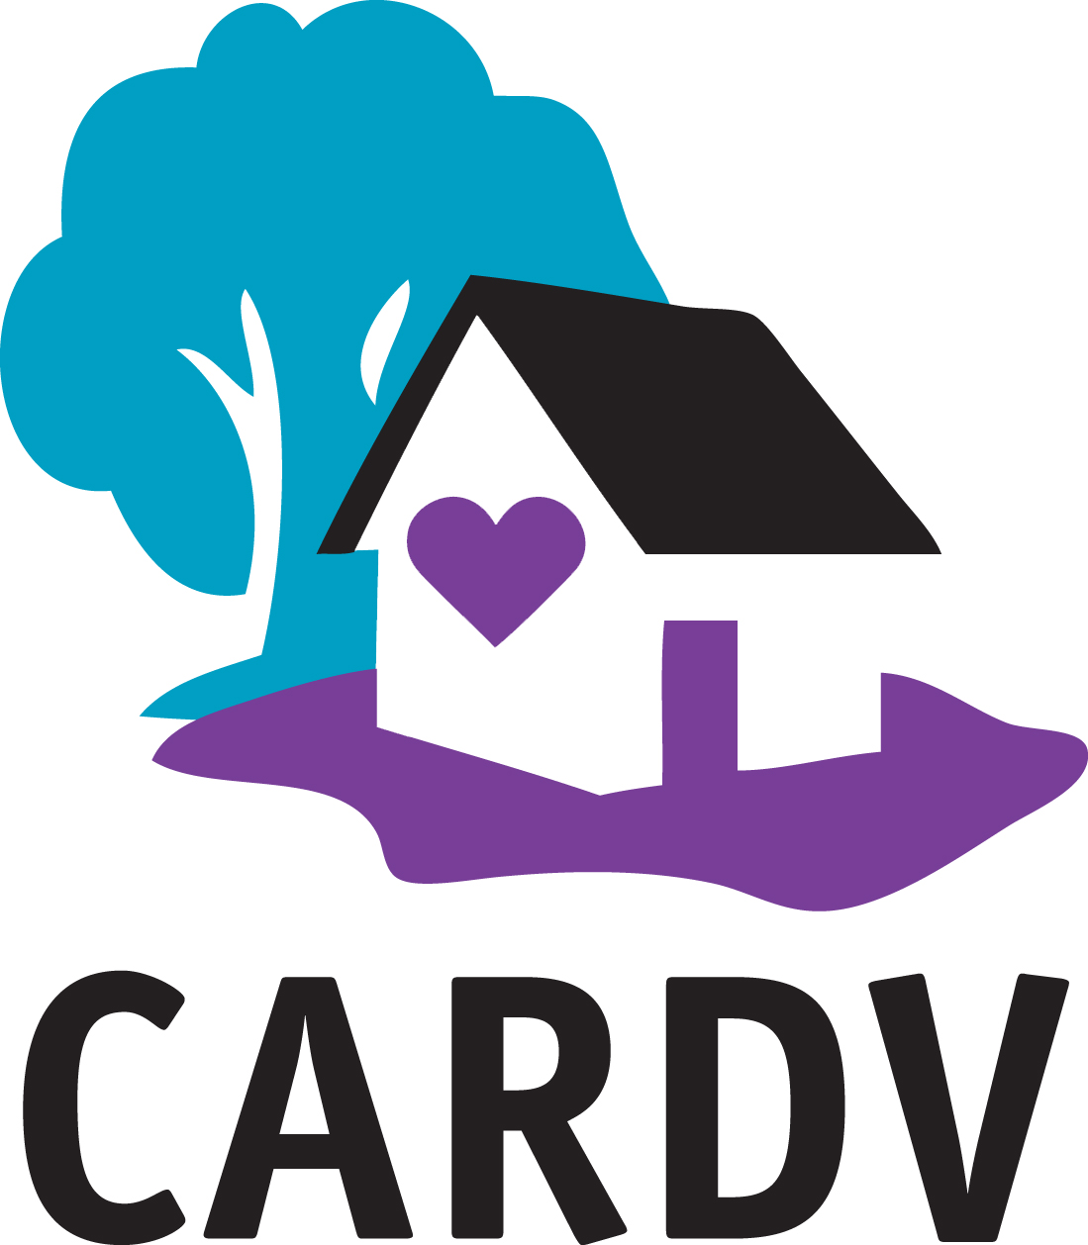
Adopted:8/31/20
Revised:__________
Revised:__________
Whistleblower Policy

Introduction
The Statement of Shared Values adopted by CARDV requires all employees and board members to observe high standards of business and personal ethics in the conduct of their duties and responsibilities.

Employees include the Executive Director, any management (including but not limited to) the Program Manager, Shelter Manager, and Crises Response Manager, Advocates, administrative staff, independent contractors contracted with CARDV, volunteers, and any other persons employed by CARDV and under the supervision of the Executive Director

As employees and representatives of CARDV, we must practice honesty and integrity in fulfilling our responsibilities and comply with all applicable laws and regulations. Set forth below is CARDV’s policy with respect to reporting good-faith concerns about the legality or propriety of CARDV actions or plans.

Reporting of Concerns or Complaints
It is the responsibility of all employees and board members to comply with applicable State and Federal law and to report violations or suspected violations in accordance with this Whistleblower Policy.

Confidentiality
CARDV will treat all communications under this policy in a confidential manner, except to the extent necessary 1) to conduct a complete and fair investigation, or 2) for review of CARDV operations by CARDV’s board, its Finance Committee, CARDV’s independent public accountants, and CARDV’s legal counsel.

Retaliation
CARDV will not permit any negative or adverse actions to be taken against any employee or individual for making a good-faith report of a possible violation of applicable law, even if the report is mistaken, or against any employee or individual who assists in the investigation of a reported violation. Retaliation in any form will not be tolerated. Any act of alleged retaliation should be reported immediately and will be promptly investigated. An employee who retaliates against someone who has reported a violation in good faith is subject to discipline up to and including termination of employment. This Whistleblower Policy is intended to encourage and enable employees and others to raise serious concerns within CARDV prior to seeking resolution outside the organization.

How to Report Concerns or Complaints
Employees and others may communicate suspected violations of applicable law, or other wrongdoing or alleged retaliation by contacting the Board Chair. In the event you do not feel comfortable speaking with the Board Chair, you may contact: Community Activist Nancy Greenman at PH 541-990-2370. Please note, however, that Ms. Greenman is not the attorney for CARDV, and there is no attorney-client privilege or duty of confidentiality between the Whistleblower, CARDV, and any reporting person. If you wish to remain anonymous, it is not necessary that you give your name or position in any notification.

Whether or not you identify yourself, for a proper investigation to be conducted, please provide Ms. Greenman with as much information as you can, sufficient to do a proper investigation, including where and when the incident occurred, names and titles of the individuals involved, and as much other detail as you can provide.

Expectations for Action
The Board Chair (as designated Board member) or Ms. Greenman, may take any of the following action to address reported violation:

- Report to the Oregon Department of Justice Charitable Services Division;
- Report to the internal Revenue Service Tax Exempt and Government Entities Division;
- Report to the appropriate law enforcement agencies;
- Report to any other appropriate governing, administrative, or enforcement bodies.

Illustrative Types of Concerns
The following is a non-exhaustive list of the kinds of improprieties that should be reported:
- Supplying false or misleading information on CARDV’s financial or other public documents, including its Form 990
- Providing false information to or withholding material information from CARDV’s board or auditors
- Destroying, altering, mutilating, concealing, covering up, falsifying, or making a false entry in any records that may be connected to an official proceeding, in violation of federal or state law or regulations
- Altering, destroying, or concealing a document, or attempting to do so, with the intent to impair the document’s availability for use in an official proceeding or otherwise obstructing, influencing, or impeding any official proceeding, in violation of federal or state law or regulations
- Embezzling, self-dealing, private inurement (i.e., CARDV earnings inuring to the benefit of a director, officer, or senior management) and private benefit (i.e., CARDV assets being used by anyone in the organization for personal gain or benefit)
- Paying for services or goods that are not rendered or delivered
- Using remarks or actions of a sexual nature that are not welcome and are likely to be viewed as personally offensive, including sexual flirtations; unwelcome physical or verbal advances; sexual propositions; verbal abuse of a sexual nature; the display of sexually suggestive objects, cartoons, or pictures; and physical contact of a sexual or particularly personal nature.
- Using epithets, slurs, negative stereotyping, and threatening, intimidating, or hostile acts that relate to race, color, religion, gender, national origin, age, or disability
- Circulating or posting written or graphic material in the workplace that denigrates or shows hostility or aversion toward an individual or group because of race, color, religion, gender, nationality, age, or disability
- Discriminating against an employee or potential employee due to a person’s race, color, religion, sex, sexual orientation, national origin, age, physical or mental impairment, or veteran status
- Violating CARDV’s Statement of Non-Discrimination, Conflict-of-Interest Policy, Harassment Policy, or Equal Employment Opportunity Policy
- Facilitating or concealing any of the above or similar actions

Questions
If you have any questions regarding this policy, please contact the Executive Director, and they will forward your questions to the appropriate person.

Board Chair: Kate Caldwell Date: 8/27/20

Staff:______________________________ Date:_______________________

